**Hello World RESTful Web Service**

HelloController.java:

*package com.cognizant.springlearn.controller;  
  
import org.slf4j.Logger;  
import org.slf4j.LoggerFactory;  
import org.springframework.web.bind.annotation.RequestMapping;  
import org.springframework.web.bind.annotation.RestController;  
  
@RestController  
public class HelloController {  
  
 private static final Logger logger = LoggerFactory.getLogger(HelloController.class);  
  
 @RequestMapping("/hello")  
 public String sayHello(){  
 logger.info("Inside sayHello method");  
 logger.info("Returning Hello World");  
 return "Hello World!!";  
 }  
}*

Main Class:

*package* com.cognizant.springlearn;  
  
*import* org.slf4j.Logger;  
*import* org.slf4j.LoggerFactory;  
*import* org.springframework.boot.SpringApplication;  
*import* org.springframework.boot.autoconfigure.*SpringBootApplication*;  
*import* org.springframework.context.ApplicationContext;  
*import* org.springframework.context.support.ClassPathXmlApplicationContext;  
  
*@SpringBootApplication  
public class* SpringLearnApplication {  
  
 *private static final* Logger LOGGER = LoggerFactory.getLogger(SpringLearnApplication.*class*);  
  
  
  
 *public static void* main(String[] args) {  
  
 SpringApplication.run(SpringLearnApplication.*class*, args);  
 LOGGER.info("Inside Main class");}  
  
}

OUTPUT:

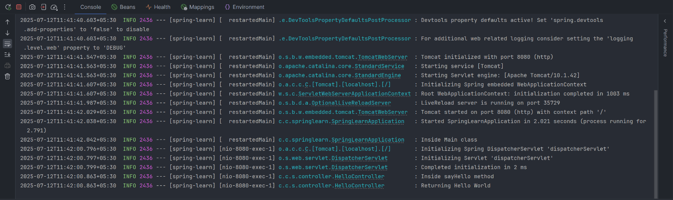

BROWSER:

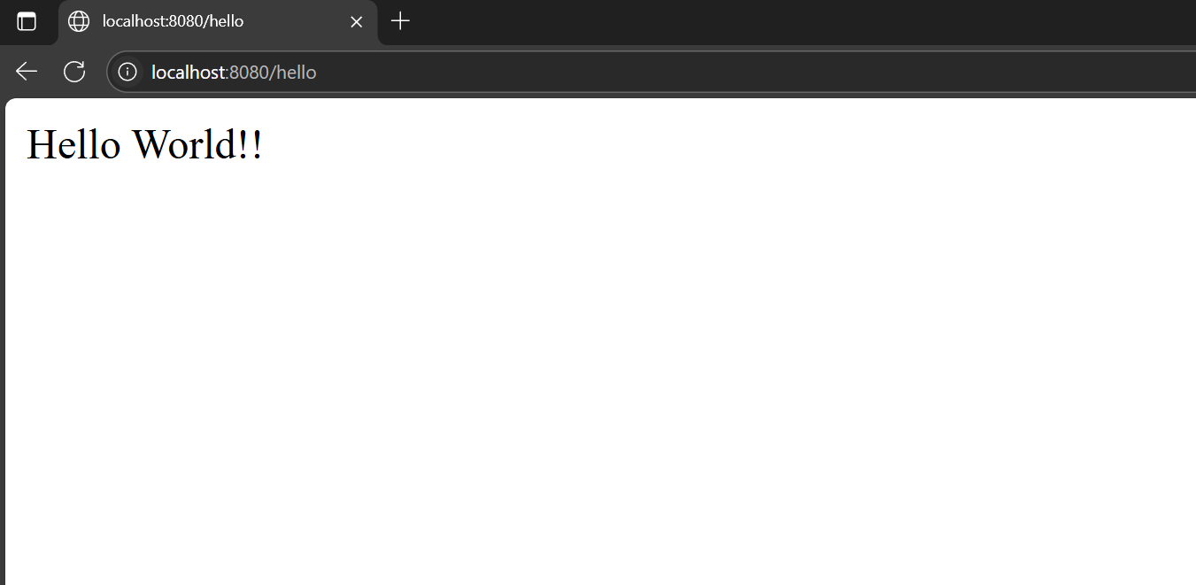

**REST - Country Web Service**

CountryController.java:

*package com.cognizant.springlearn.controller;  
  
import com.cognizant.springlearn.Country;  
import org.slf4j.Logger;  
import org.slf4j.LoggerFactory;  
import org.springframework.context.ApplicationContext;  
import org.springframework.context.support.ClassPathXmlApplicationContext;  
import org.springframework.web.bind.annotation.RequestMapping;  
import org.springframework.web.bind.annotation.RestController;  
  
@RestController  
public class CountryController {  
  
 private static final Logger logger = LoggerFactory.getLogger(CountryController.class);  
  
 @RequestMapping("/country")  
 public Country getCountryIndia(){  
 logger.info("Inside getCountryIndia method");  
 ApplicationContext context = new ClassPathXmlApplicationContext("country.xml");  
 Country country = context.getBean("in",Country.class);  
 logger.info("Country : {}",country);  
 return country;  
 }  
}*

Main Class:

*package* com.cognizant.springlearn;  
  
*import* org.slf4j.Logger;  
*import* org.slf4j.LoggerFactory;  
*import* org.springframework.boot.SpringApplication;  
*import* org.springframework.boot.autoconfigure.*SpringBootApplication*;  
*import* org.springframework.context.ApplicationContext;  
*import* org.springframework.context.support.ClassPathXmlApplicationContext;  
  
*@SpringBootApplication  
public class* SpringLearnApplication {  
  
 *private static final* Logger LOGGER = LoggerFactory.getLogger(SpringLearnApplication.*class*);  
  
  
  
 *public static void* main(String[] args) {  
  
 SpringApplication.run(SpringLearnApplication.*class*, args);  
 LOGGER.info("Inside Main class");}  
  
}

OUTPUT:

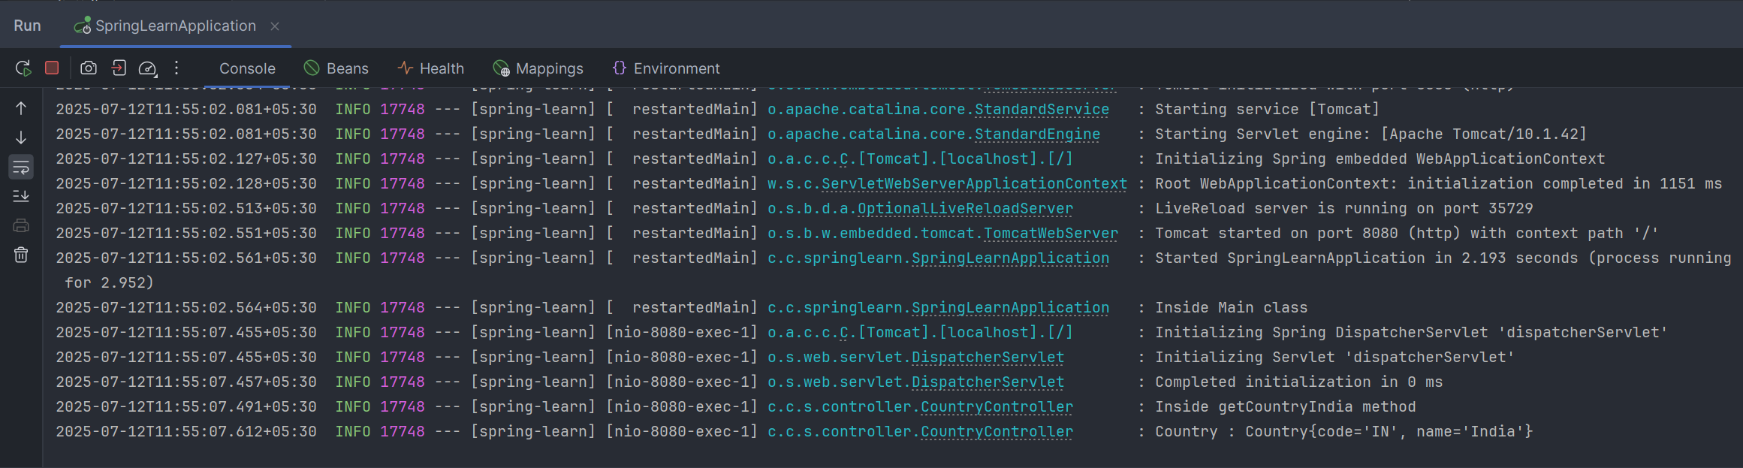

BROWSER:

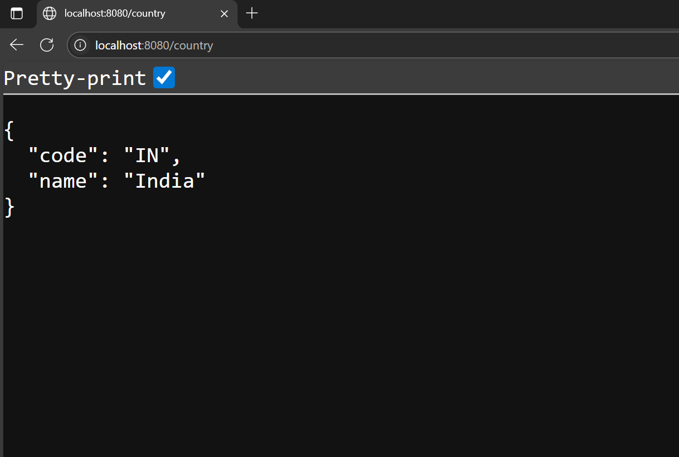

**REST - Get country based on country code**

We create a list of countries in **country.xml** file.

Country.xml:

<?xml version="1.0" encoding="UTF-8"?>  
<beans xmlns="http://www.springframework.org/schema/beans"  
 xmlns:xsi="http://www.w3.org/2001/XMLSchema-instance"  
 xsi:schemaLocation="http://www.springframework.org/schema/beans http://www.springframework.org/schema/beans/spring-beans.xsd">  
  
  
 <bean class="com.cognizant.springlearn.Country" id="in">  
 <property name="code" value="IN"/>  
 <property name="name" value="India"/>  
 </bean>  
  
 <bean class="com.cognizant.springlearn.Country" id="us">  
 <property name="code" value="US"/>  
 <property name="name" value="United States"/>  
 </bean>  
  
 <bean class="com.cognizant.springlearn.Country" id="de">  
 <property name="code" value="DE"/>  
 <property name="name" value="Germany"/>  
 </bean>  
  
 <bean class="com.cognizant.springlearn.Country" id="jp">  
 <property name="code" value="JP"/>  
 <property name="name" value="Japan"/>  
 </bean>  
  
 <bean id="countryList" class="java.util.ArrayList">  
 <constructor-arg>  
 <list>  
 <ref bean="in"/>  
 <ref bean="us"/>  
 <ref bean="de"/>  
 <ref bean="jp"/>  
 </list>  
 </constructor-arg>  
 </bean>  
  
  
</beans>

CountryController.java

*package* com.cognizant.springlearn.controller;  
  
*import* com.cognizant.springlearn.Country;  
*import* com.cognizant.springlearn.service.CountryService;  
*import* org.slf4j.Logger;  
*import* org.slf4j.LoggerFactory;  
*import* org.springframework.beans.factory.annotation.*Autowired*;  
*import* org.springframework.context.ApplicationContext;  
*import* org.springframework.context.support.ClassPathXmlApplicationContext;  
*import* org.springframework.web.bind.annotation.*GetMapping*;  
*import* org.springframework.web.bind.annotation.*PathVariable*;  
*import* org.springframework.web.bind.annotation.*RequestMapping*;  
*import* org.springframework.web.bind.annotation.*RestController*;  
  
*@RestController  
public class* CountryController {  
  
 *private static final* Logger logger = LoggerFactory.getLogger(CountryController.*class*);  
 *@Autowired  
 private* CountryService service;  
  
 *@RequestMapping*("/country")  
 *public* Country getCountryIndia(){  
 logger.info("Inside getCountryIndia method");  
 ApplicationContext context = *new* ClassPathXmlApplicationContext("country.xml");  
 Country country = context.getBean("in",Country.*class*);  
 logger.info("Country : {}",country);  
 *return* country;  
 }  
  
 *@GetMapping*("/countries/{code}")  
 *public* Country getCountry(*@PathVariable*(name = "code") String code){  
 logger.info("Inside getCountry method");  
 *return* service.getCountry(code);  
 }  
}

CountryService.java:

*package* com.cognizant.springlearn.service;  
  
*import* com.cognizant.springlearn.Country;  
*import* org.springframework.context.ApplicationContext;  
*import* org.springframework.context.support.ClassPathXmlApplicationContext;  
*import* org.springframework.stereotype.*Service*;  
  
*import* java.util.ArrayList;  
  
  
*@Service  
public class* CountryService {  
  
 *public* Country getCountry(String code){  
 ApplicationContext context = *new* ClassPathXmlApplicationContext("country.xml");  
  
 ArrayList<Country> countries = context.getBean("countryList", ArrayList.*class*);  
  
 Country searchedCountry = *null*;  
 *for*(Country country: countries){  
 *if*(country.getCode().equalsIgnoreCase(code)){  
 searchedCountry = country;  
 *break*;  
 }  
 }  
  
 *return* searchedCountry;  
 }  
}

OUTPUT:

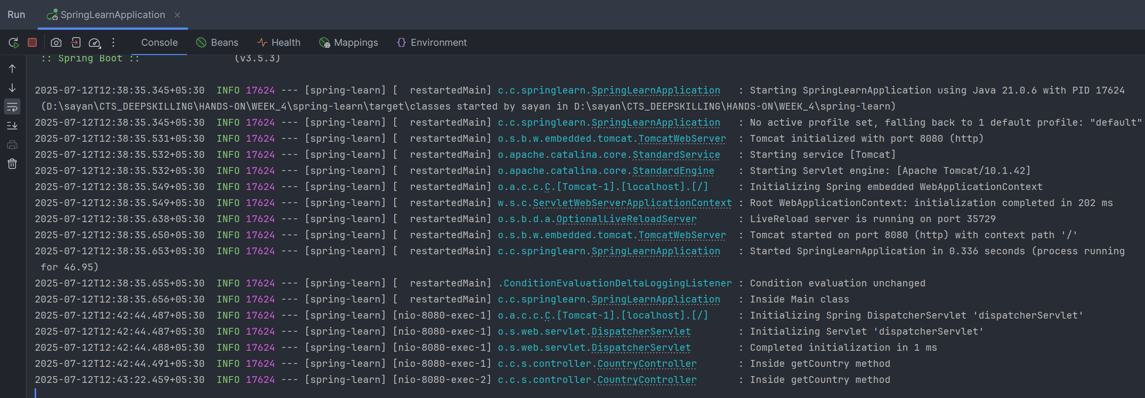

BROWSER:

